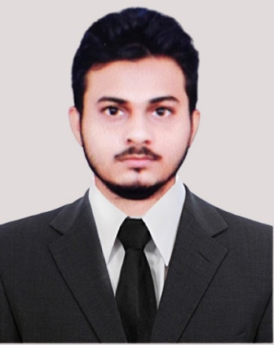

**EDUCATION**

B.E in Computer Science| Chandigarh University,Gharuan, Punjab

*Session: 2020-2024 | Score:* ***8.07 CGPA***

Intermediate (CBSE) |Children Senior Secondary School, Azamgarh, UP

*Session: 2018-2019 |Score:* ***7.50 CGPA***

Matriculation (CBSE) |Children Senior Secondary School, Azamgarh, UP

*Session: 2016-2017 |Score:* ***7.8 CGPA***

**PROJECTS**

**Heart Disease Detection using Machine Learning(python): [**[**GITHUB Link**](https://github.com/mohdali770409/Heart-Disease-Detection-Using-Machine-Learning)**]**

A **classification model** which detects whether a person have heart disease or not with a **88% of accuracy**

**Tools Used**: Pandas | Matplotlib | NumPy | Scikit Learn

**Final Model Used:** Random Forest Classifier  *FEB 2023*

***Flowerence Website: [[Host Link](http://flowerence.great-site.net/)]***

*A Hospital website where you can register, send message and donate using HTML5, CSS3, BOOTSTRAP5, JAVASCRIPT JULY 2023*

**Spam Mail Detection using Machine Learning(python): [**[**GITHUB Link]**](https://github.com/mohdali770409/Spam-Mail-Detection-using-Machine-Learning)

A **classification model** which detects whether a mail is spam or not with **100% of precision and 97% accuracy**

**Final Model Used:** KNN

*MARCH 2023*

**Bulldozer Price predictor using Machine Learning(python): [**[**GITHUB Link**](https://github.com/mohdali770409/Bull-dozer-price-predictor)**]**

A **regression model** which predicts the price of Bulldozers **with 0.88 r square score**

**Final Model Used:** Random Forest Regressor*April 2023*

**ACHIEVEMENTS**

* **Solved 420+ Data Structures problems** of GFG **[**[**Proof Link**](https://auth.geeksforgeeks.org/user/mohdali770409/practice)**]**
* **Ranking at** **169h Position** at GFG(DSA Problem Solving-Institute Rank) **[**[**Proof Link**](https://auth.geeksforgeeks.org/user/mohdali770409/practice)**]**
* Qualified Persistent system coding round 2023
* Cracked **CodeKaze**(by coding ninjas) first round 2023
* Developed and curated **150+ GFG DSA** **solutions** with detailed explanations on GitHub **[**[**GitHub Proof Link**](https://github.com/mohdali770409/GFG-Solutions)**]**
* Qualified Wipro Technical Round, 2022

**CERTIFICATIONS**

* Learn C++ Programming -Beginner to Advance by Abdul Bari (Udemy)
* Mastering Data Structures & Algorithms using C and C++ by Abdul Bari (Udemy)
* Complete Machine Learning & Data Science bootcamp by ZTM
* **CodeKaze** Participation certificate by coding ninjas, june 2023

**MOHD ALI**

**Address**:

Vill-Khalispur,Post-Shekhupur,Dist Azamgarh,276001

**Phone**:9838266316

**Email**:mohdaliofficial7704@gmail.com

**LinkedIn**: [[LinkedIn link](https://www.linkedin.com/in/mohd-ali-6859951b2/)]

**GitHub**:[[GitHub Link](https://github.com/mohdali770409?tab=repositories)]

**PROFESSIONAL SUMMARY**

Interested in the role of Software Engineer where I can contribute my technical, analytical and knowledge acquired by pursuing my degree in Software Engineering

**TECHNICAL SKILLS**

**C | C++ |Python**

**Data Structure & Algorithms**

**Machine Learning**:Pandas | Numpy | MatPlotLib | Scikit Learn

**Web Development(BASIC):**HTML | CSS | NodeJS | API

**INTERPERSONAL SKILLS**

Decision Making | Team Collaboration |

Team Cooperation | Deep Thinker |

Consistent

**INTERESTS & HOBBIES**

Trading | Investing | Book Reading

**LANGUAGES KNOWN**

English **|** Hindi **|** Urdu (Read & Write)

Arabic (Read)

**TECHNICAL SUBJECTS**

**Computer Networks | Operating System | DBMS | OOPS**